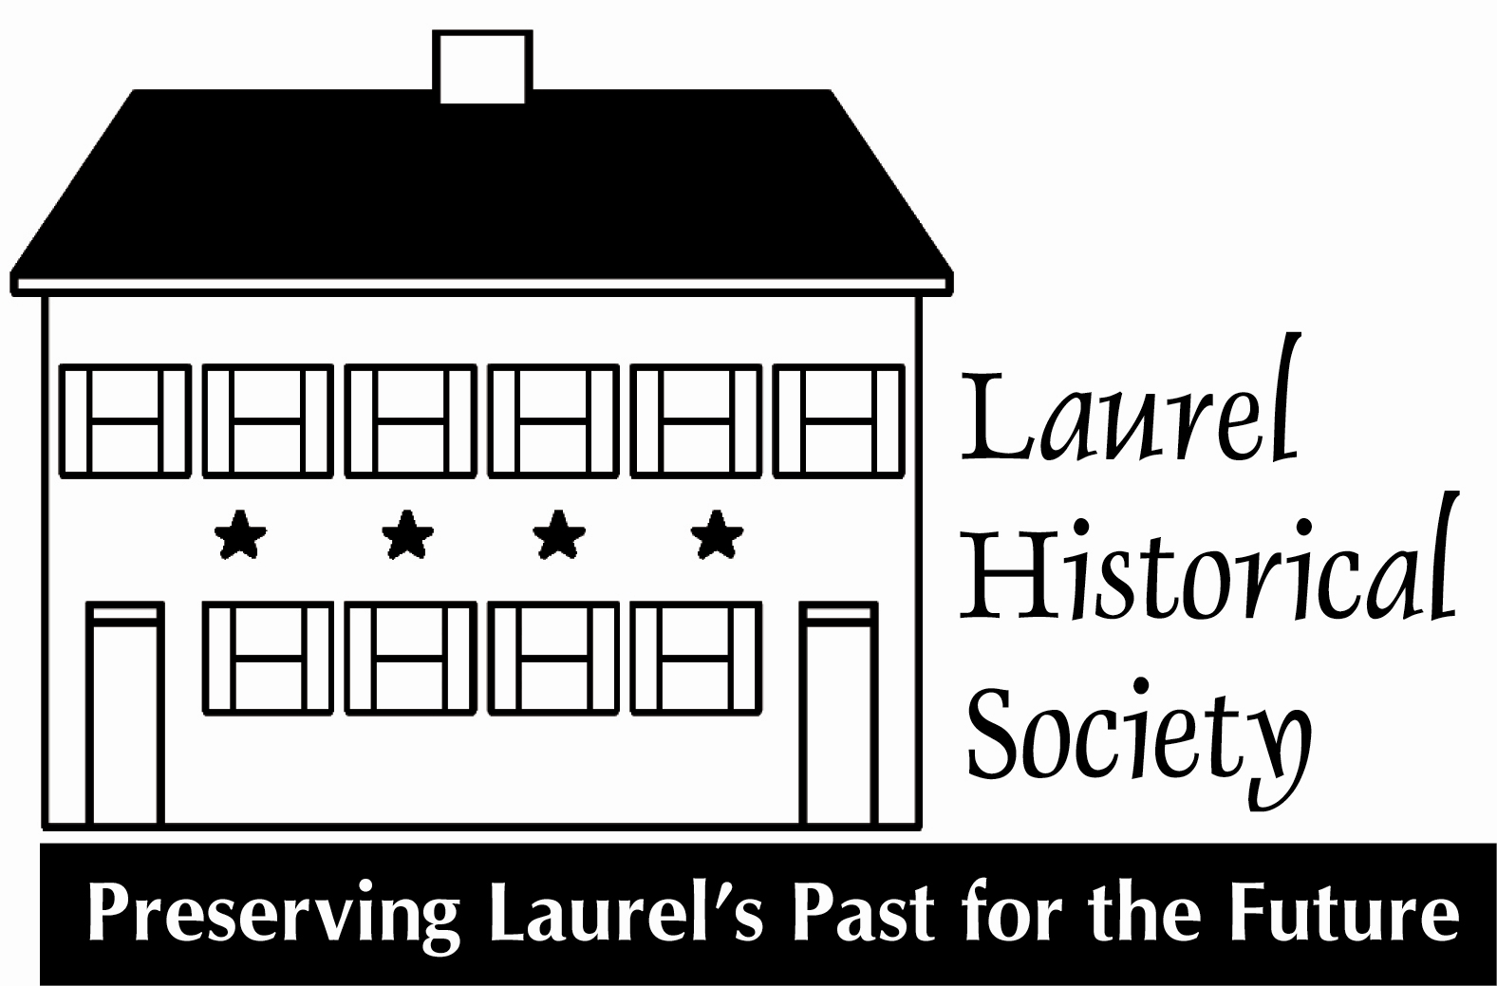

March 2017

Dear Laurel Historical Society Members and Friends:

Please join us for our annual community fundraising gala, “The Great Gala”, in keeping with our 2017 museum exhibit theme, WWI, honoring the contributions of Laurel and our home town heroes. We look forward to your attendance and support on the evening of Saturday, April 22 from 6:00 to 10:00 pm at the newly remodeled Double Tree Hotel on Sweitzer Lane.
Board of Directors

Officers
Jhanna Levin
Chair

Steve Hubbard
President

Frances Brooks
Vice-president

Mariam Thakkar Treasurer

Marlene Frazier
Recording Secretary

Amy Graver
Corresponding Secretary

Elizabeth Compton
Co-founder

Members
Jeanie Anastasi
Mitzi Betman
Mike Boivin
Tom Dernoga
Chris Erdle
Lisa Everett
Alicia Fields
Abram Fox
Richard Friend
Karen A. Lubieniecki
Margie McCeney
Paula Schumann

Mayor, Craig Moe
Ex Officio

Gertrude L. Poe Director Emeritus

Joseph Robison Director Emeritus

Jean Wilson
Director Emeritus

Your support is vital to the sustainability of the Laurel Historical Society, the sole organization in the City of Laurel charged with curating, preserving, and promoting Laurel’s historic journey, continued evolution, and contributions to our community and the state

The Silent Auction is one of the evening’s highlights. Attendees rush in to see what is on the auction tables. Gift certificates, vacation rentals, one-of-a-kind items, antiques, and objects with particular Laurel connections are especially desirable. We will have another Live Auction this year as well.

Your donation of any item would be most appreciated. All of our contributors are acknowledged at the Gala, in the Commemorative Booklet, in the Society’s newsletter, The Laurel Light, as well as on our website.

In addition to the Silent Auction we sponsorship opportunities varying in price from Signature Sponsor at $5,000 to Individual Auction Tables at $300. All sponsorship levels will showcase your name at the Gala, in the Laurel Light Newsletter, and our website. The “Great Gala” promises to be a fun evening with great food, music, friends, neighbors and silent and live auctions to support our great Laurel community.

More information can be found on our website www.laurelhistoricalsociety.org or you can contact us at the Laurel Museum 301-725-7975. Board members, advocates, and friends of the Laurel Historical Society are also great sources of information.

Your participation is more important than ever. We look forward to hearing from you and will reach out to follow-up on your attendance and support. See you there!

Kindly,

The Gala Committee

