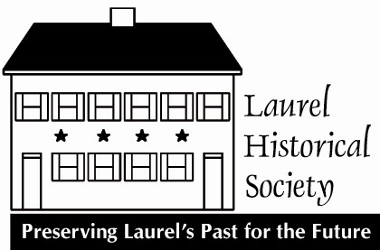
The Laurel
Light
News and History from the Laurel Historical Society
The mission of the Laurel Historical Society, Incorporated is to encourage the understanding and preservation of the history and cultural heritage of Laurel.

A BABY BORN TO THE EXECUTIVE DIRECTOR

The Laurel Historical Society sends congratulations and many blessings to Lindsey Baker and Danny Cruz on the birth of their beautiful daughter! Born on September 15th at 3:56 AM and sporting a full head of hair! She looks super smart already!!

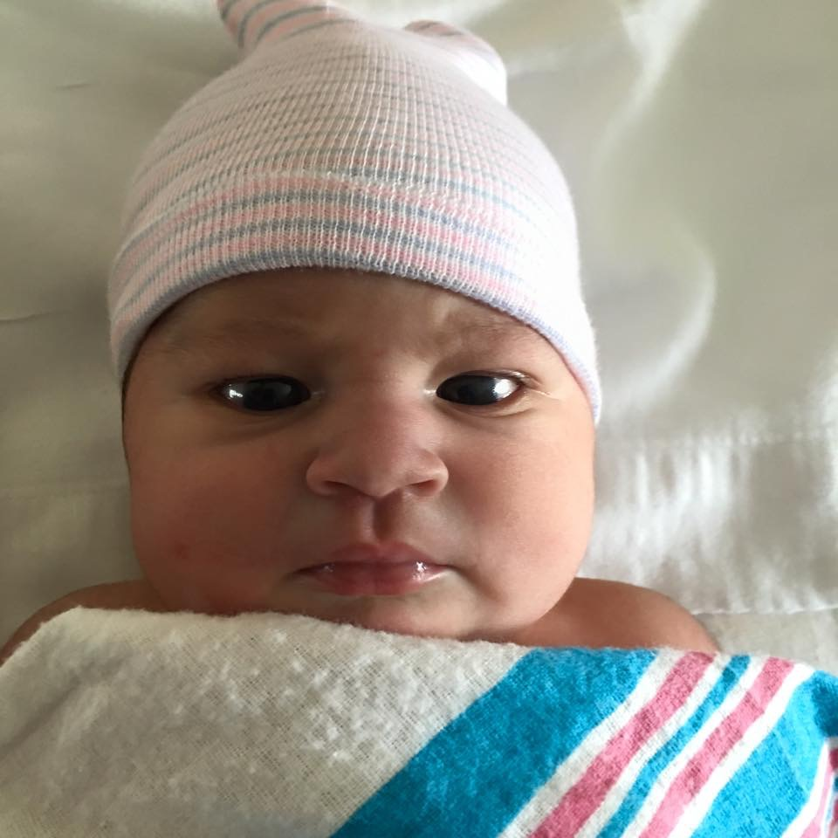

Adriana Lily Cruz, 10lbs 1.5 oz, 22 inches

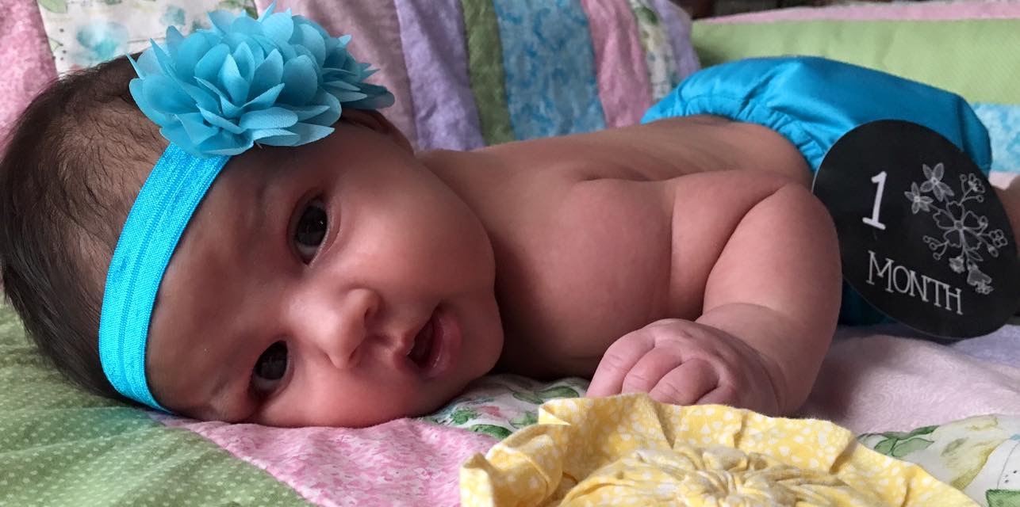

PROUD PARENTS Lindsey Baker and Danny Cruz

November 2016
Volume XVII,Number IV
The Laurel Light
Published Quarterly by:
The Laurel Historical Society, Inc.
817 Main St. Laurel, MD 20707-3429

A MESSAGE FROM THE CHAIRMAN OF THE BOARD

Happy Holidays!!

As the weather gets colder and we wind down this year's exhibit, I reflect on all that has occurred this year.

We wanted to create an event that would honor Jim's memory as well as leave a mark on the community as he did. Our inaugural McCeney March was a great success. Over 60 people (dogs and babies too) joined us on a 5K walk around the historic district. Thanks to Revere Bank and a new partnership with Joe @ Sips, the newest coffee house in town (C Street), we had a great gathering after the walk. The pastries and sandwiches were delicious. We raised enough money to start our new college scholarship fund in Jim's name. Please join us again next year to continue the momentum. Thank you to our participants and sponsors.

The Board of Directors meets quarterly and this year has been full of changes. Among those adjustments, we welcome our newest Board Member, Alicia Fields of Revere Bank. We are very excited about her joining us. She brings a much appreciated business-minded skill set to our board. We created 2 new task forces: Volunteers and Personnel Manual. They are both working hard.

Help Wanted: a bookkeeper (less than 20 hours per month).

Gala: Check your mail soon!

Jhanna Levin

BOARD MEETING SCHEDULE

LHS Board meetings are held the 4th Thursday of each January, April, July, and October. The next meeting is January 26, 2017. Members are welcome to attend. They are held in the Pool Meeting Room at 7:30 PM.
FIRST ANNUAL McCENEY MARCH
The first annual McCeney March in October proved to be quite a success with dozens of people walking through the City of Laurel along a 3-mile path through Old Town. The beautiful fall day began and ended at the Laurel Museum followed by a gathering of friends and family at Sip on C Street. Refreshments were provided by Revere Bank. Proceeds from the march will be used for a college scholarship. Many thanks to all the participants, donors and sponsors including Council Woman Mary Lehman, Dividend, Academy Ford, Marlene and Jim Frazier, Wilson-Hubbard Family, Karen Lubieniecki and Ken Skrivseth, Resource Enterprises, Main Street Pharmacy, Herb & Penny Phelps, Laurel Main Street Properties, Mike Leszcz, Revere Bank, The McCeney Family, George and Natalie McCeney, Thomas Lynch, Anne Towne, Shari Pollard, Tracey Scagliarini, Lindsey Baker and Danny Cruz, Joe Murchison, The Lilienthal Family, Tom and Maggie Downs, Jeanie Anastasi, Snow Hill Garden Club and Cecil and McGowan.
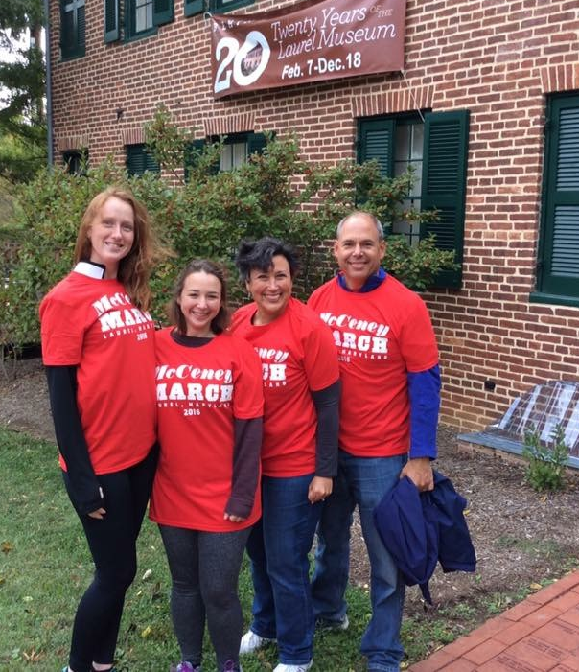 McCeney marchers! Photo courtesy of the City of Laurel
From the McCeney Family:
Thank you to everyone who turned out for the first ever McCeney March and to all the sponsors. We were overwhelmed. It was wonderful to see the enthusiasm Jim had for Laurel reflected in so many faces that Saturday morning. While none of the McCeneys was able to complete the walk, we were there at the beginning and the end. Jim would really appreciate the range of ages of the participants - from a few months to late 70s. What a wonderful way to remember him!

Bobbi, Margie, George, and Natalie
Holiday Open House at the Laurel Museum
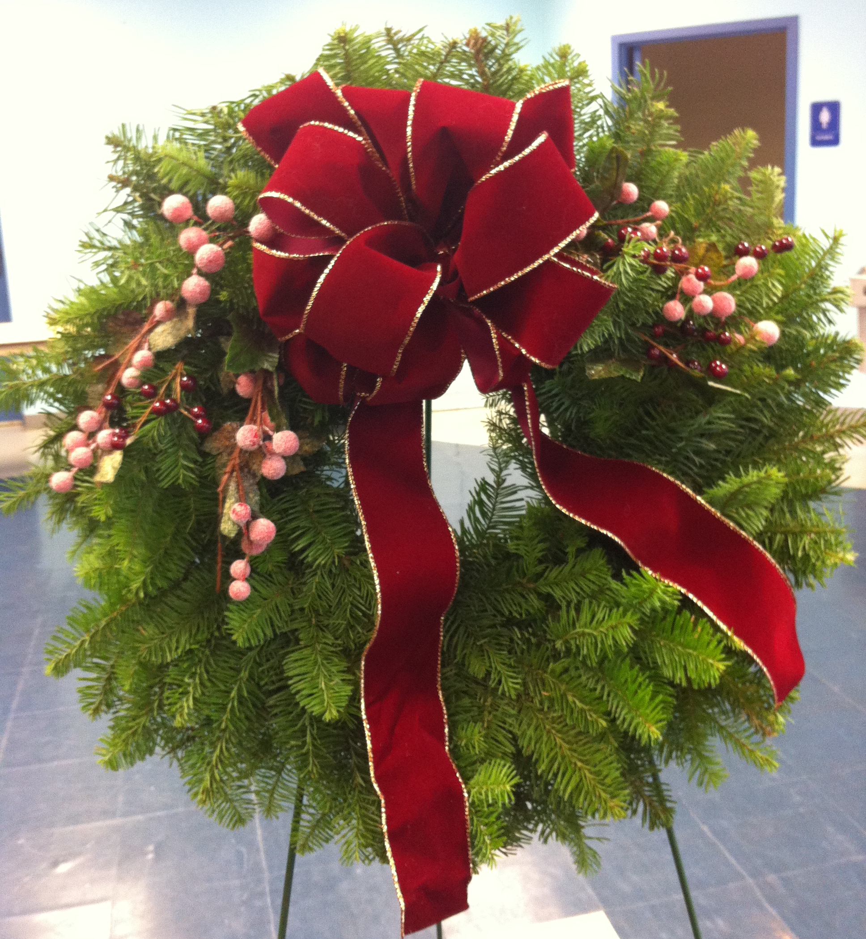
Friday, Saturday and Sunday December 2nd, 3rd and 4th
The Laurel Museum is hosting its traditional Open House Friday, Saturday and Sunday December 2nd – 4th including refreshments and a wonderful shopping experience. The Laurel Museum gift shop is a treasure trove of items for your holiday gift giving. There is a new Laurel Theater ornament (plus past years ornaments), Lost Laurel books, throws, jewelry, special gifts and more. The newest holiday ornament features the recently demolished Laurel Theater as it looked when it opened in October of 1929. The Snow Hill Garden Club will also be offering beautiful and fragrant hand-decorated wreaths. All proceeds benefit the LHS. Wreaths must be ordered in advance and cost $35. Children are not forgotten, and the museum shop features a wide array of historical toys and books. There are also “I Love Laurel” t-shirts and onsies for the “Made in Laurel” babies on your gift list.

Many of the shop items can be purchased online at laurelhistoricalsociety.org. December 16th is the last day to purchase online for holiday delivery. Open House hours are Friday and Saturday December 2nd and 3rd from 10 AM - 2 PM and Sunday December 4th from 1 – 4 PM.

Early Development of the Laurel Historical Society and Museum 1970 - 1996
By Elizabeth L. Compton

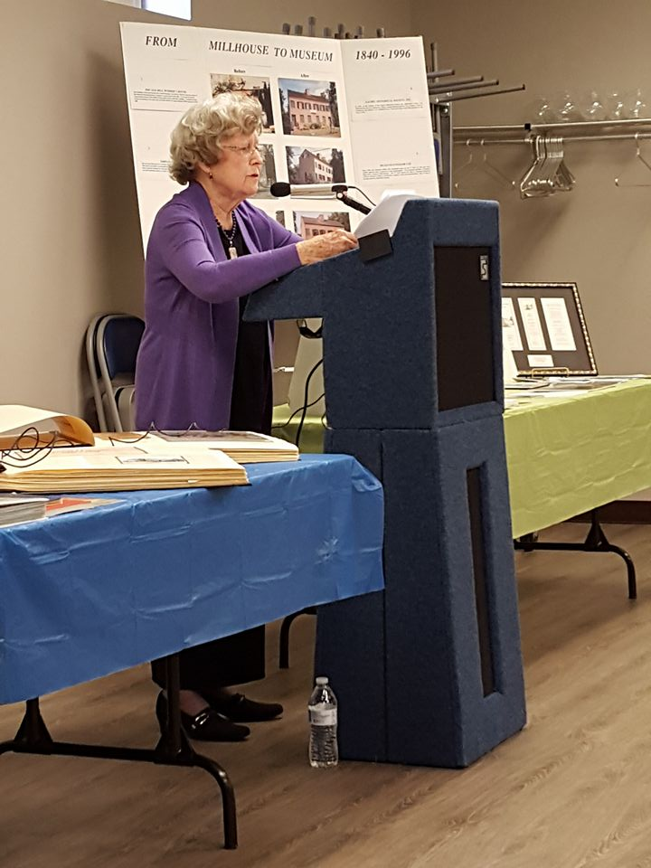
Co-Founder Betty Compton presents at talk on November 6th
Photo by Karen Lubieniecki

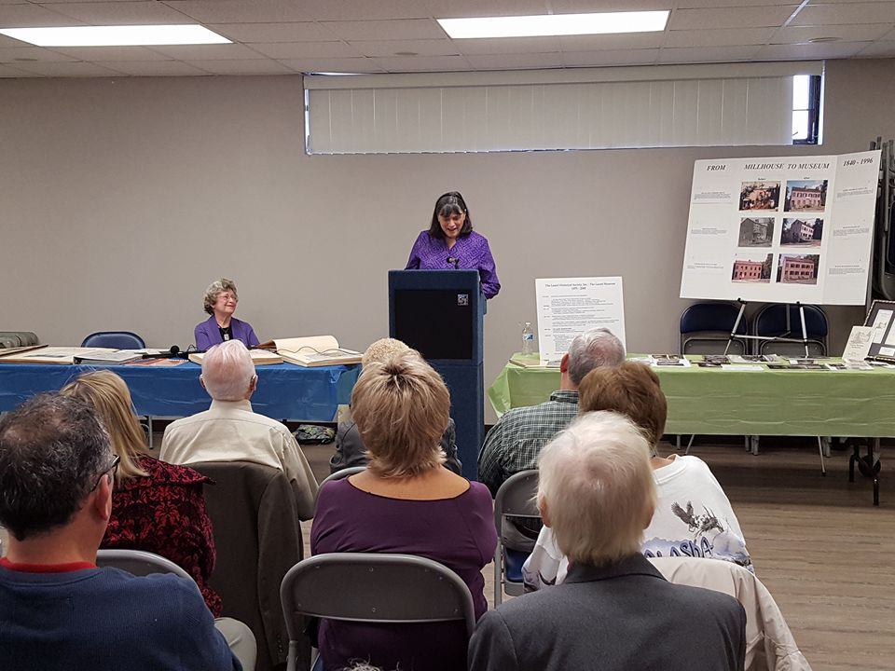
Co-presenter Marlene Frazier at talk on November 6th
Photo by Karen Lubieniecki

The following is a time line of the Early Development of the Historical Society and Museum:

1970 Laurel Celebrated the Centennial of its Incorporation.

History of Laurel Book by Editor of Laurel Leader, Gertrude Poe.
1973 Laurel applied for national and state recognition as a Bicentennial Community.

1974 Mayor Leo Wilson appointed the first Bicentennial Commission in the State of Maryland. Twelve members encouraged and assisted the community to initiate programs with 3 themes:
Festivals: to celebrate the 200th anniversary of the founding of our nation
Heritage: to promote the knowledge and appreciation of our local history
Horizon: to develop long range & enduring projects to preserve the history of our community

1975 Laurel Horizon Society formed; name changed to Laurel Historical Society in 1979.

First of Annual Laurel House Tours, Historical Exhibits in Citizens National Bank, the Library & City Hall.

Visit to Shaw Building in Annapolis, Headquarters of Maryland Historic Trust revealed only 2 photos of Laurel, one mislabeled. Subsequently the first modern photographic survey was taken by Prince Georges County Historian, Michael Dwyer, John Brennan and Betty Compton. Survey showed that Laurel has the greatest concentration of 19th Century structures in the county.

1976 General Clare E. Hutchins, Maryland Bicentennial Commissioner accepted Laurel's invitation (among many others), on July 4, 1976. He was the Grand Marshall of the Parade and returned for the Great Ball with his family all dressed in Colonial costume. Culmination of a successful Bicentennial Celebration in Laurel with lasting historical effects.

Historic Districting Legislation enacted with Laurel Horizon input.

1979 Old Laurel High School and Avondale Mill placed on National Register of Historic Places with help of LHS members.

1982 Feasibility Study of Old City Hall (former Fire House at 9th and Montgomery Streets). Safety of museum collections stored there threatened due to leaking roof and many stairs. Museum collections moved temporarily to Sadler's Pharmacy on Main Street.

B&O Railroad Station marker dedicated at first Main Street Festival.

1983 HELM Account, Help Establish Laurel Museum fundraising underway.

1985 City purchased "Oldest House in Laurel" (Millworker’s House 9th and Main Streets).

1988 Alice Merrill, Administrator of Historical and Cultural Programs determines the Society eligible for funding and other assistance from Maryland Historical Trust.

1991 Exterior restoration continued on museum. Mayor Joe Robison and City Council passed Resolution 491 which dedicated the Millworker’s House for use as a museum thereby making the LHS eligible for funds from the newly formed MD Museum Assistance Program.

LHS became Incorporated and obtained non-profit status.

1992 Consultants Grant awarded for the Interpretive Plan, a prerequisite for future grants. A Museum Director once told us that the first grant is like getting the first olive out of the jar, after that it is easier.

1993 Betty Compton testified before the MD Senate Finance Committee to describe the restoration efforts and volunteers who supported the establishment of a Laurel Museum. Soon after the State met the City's funds totaling $300,000 for the interior construction.

Laurel Department of Parks and Recreation offered the Society space in the Armory to store the artifacts of the museum. This secure working area gave Jane Cole, Clare Bergeron and Penny Phelps the opportunity to catalog every item thus far donated. They diligently worked many hours and had every item already accessioned before moving to the museum.

MD Humanities Grant for Video " Historic Crossroads". This 18 minute video won a
Silver Award in the Awareness Building category from the American Association of Museums. The marble award was picked up at the Annual Meeting in Seattle, WA by the Comptons. It was shown over the three day meeting to attendees. Membership in the AAM at that time was 3500.

1994 Archeological exploration of the museum's exterior and interior completed unearthing interesting artifacts giving insight to previous residents lives.
Marlene Frazier, met with the contractors on the museum interior restoration from the beginning also met with the archeologist. She has devoted much of her life to the LHS through the years as Treasurer, Collection Committee Chair, Board Member and Secretary, House Tour Chair and more.

1995 Architectural historian's survey completed.

Consultants hired with grants from MD Historic Trust, MD Humanities, MD Museum Assistance Program and other agencies to intermittently guide volunteers. An Interpretive Plan as well as other prerequisites for further funding were accomplished. Laurel Historical Society members focused on the business of how to operate a museum as well as a research library. Volunteers worked thousands of hours with professional museum specialists, curators, attending conferences, learning proper accessioning techniques and other policies in an effort to increase their collective knowledge on all aspects of museum development and management.

First Museum Director hired. Volunteers were then worked on assisting the Director, serving on committees, as Board of Trustee Members, planning and mounting annual exhibits and the myriad other possible activities to preserve and appreciate the unique history of our beloved community of Laurel.

1996 Prince Georges County celebrated its 350th Anniversary. One of the major events was the Passport Program where citizens would visit all the historically designated places.
Even though Laurel Museum would not open until May 1996, we were invited to be a part of the program and the picture and information about the new Laurel Museum was included. This gave the first year's attendance to the museum a real boost.

1996 The doors to the Laurel Museum were opened May 4, 1996

To quote a history written by Melanie Dzwonchyk
"The Laurel Historical Society may have been born of necessity, but was nurtured by the enthusiasm of volunteers dedicated to preserving and understanding Laurel's past. These volunteers have managed to create a permanent reminder of Laurel's historic and natural heritage, going beyond the horizon with long range and enduring projects that guarantee a place for
Laurel's future."

Thank you Betty Compton and Jane Cole and the countless number of volunteers that have worked tirelessly to preserve the history of Laurel for the future.

MUSEUM NEWS

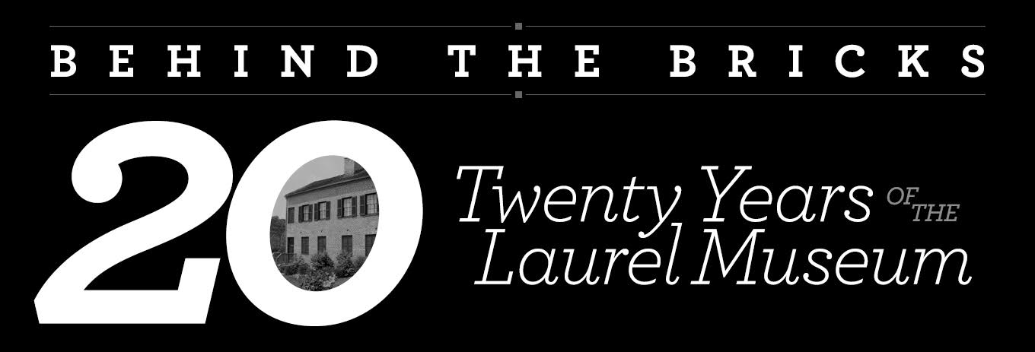

Last Chance: “Behind the Bricks: The Laurel Museum at 20”

Celebrating 20 years of the Laurel Museum, Behind the Bricks: 20 Years of the Laurel Museum will close for good Sunday, December 18th. The exhibit demonstrates how exhibits are created. For LHS members, it’s a way to walk down memory lane and recall some of the society’s most memorable exhibits. And for those new to the organization, a chance to see what you missed the past 20 years! Stop by while you’re doing your holiday shopping at the gift shop!

The next exhibit, "Laurel's World War I: From Here to Over There" opens in February.

MEMBER NEWS

Please welcome our newest members:
Amina Baig
Linda Blucher
Andrea Casula
Mickey R. Evans
Nichols & Hurtt, LLP, Stewart M. Hurtt
Steve Labash & Susan Davis
Jan Loftus
McGowan & Cecial, LLC, Michael McGowan, Attorney at Law
Phill Wilder

We are happy to have you!

Membership Committee

Do you have ideas about how we can make membership in the LHS more meaningful? Contact Membership Chair Mike Boivin at mikeb98159@aol.com or by phone at 301-385-6090. Thank you.

Welcome New Volunteers

Rebecca Krieger

THANK YOU REBECCA!!

The Laurel Museum is in need of volunteers for the first and third Fridays of each month. The hours are 10 am - 12 pm for the first shift and 12 pm - 2 pm for the second shift. Volunteers will greet the public, give tours, and/or handle sales in the gift shop. Training is available. For more information, please contact Monica at assist@laurelhistoricalsociety.org or 301-725-7975.

DID YOU KNOW?

STANLEY PLACE THAT RUNS BETWEEN PRINCE GEORGE STREET AND MONTGOMERY STREET WAS RENAMED NOVEMBER 2, 1920 FROM THE FORMER STREET NAME OF COLLINS STREET. ADDITIONALLY, MONTGOMERY STREET WAS RENAMED MONTGOMERY AVENUE BUT THAT STREET NAME CHANGE NEVER TOOK PLACE AS THOSE WHO RESIDE ON MONTGOMERY STREET KNOW!

Museum Shop News
2015 Ornament Now Available Depicting The Laurel Theater: 1929

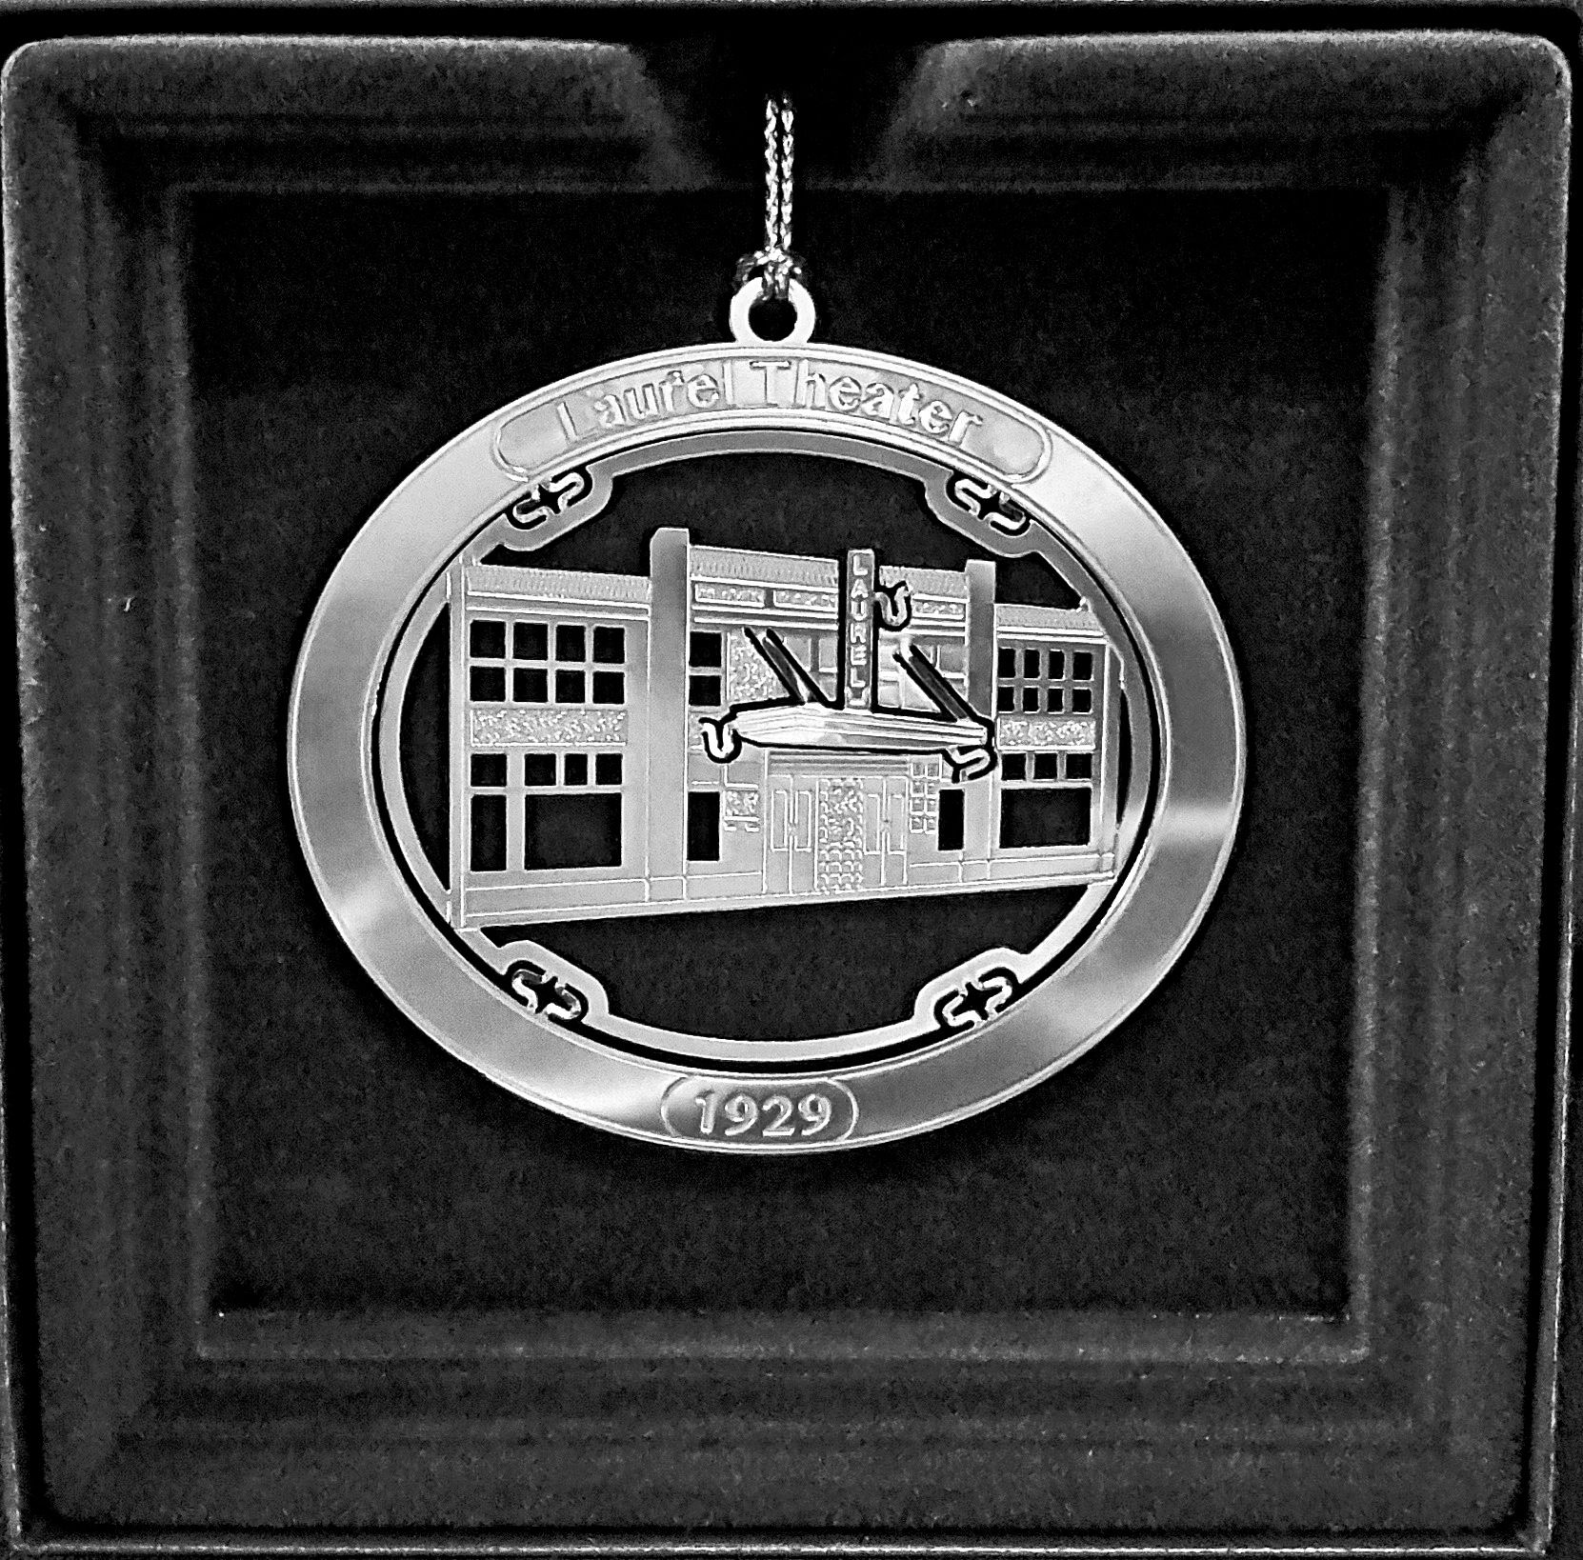
Laurel Theater 2016 Ornament
Our 2016 holiday ornament features the recently demolished Laurel Theater as it looked when it opened in October of 1929. The first movie shown there was "Noah's Ark," starring Myrna Loy and Noah Beery, and was the screen debut of a then unknown John Wayne. The theater was a popular Laurel landmark for many years. Its movie theater life ran until 1976. The Petrucci family transformed it into Petrucci’s Dinner Theater from 1977 to 1992. From 1992-2007 it was a series of comedy clubs. The doors closed for good in 2007. The building was purchased by the City of Laurel and demolished in 2016.
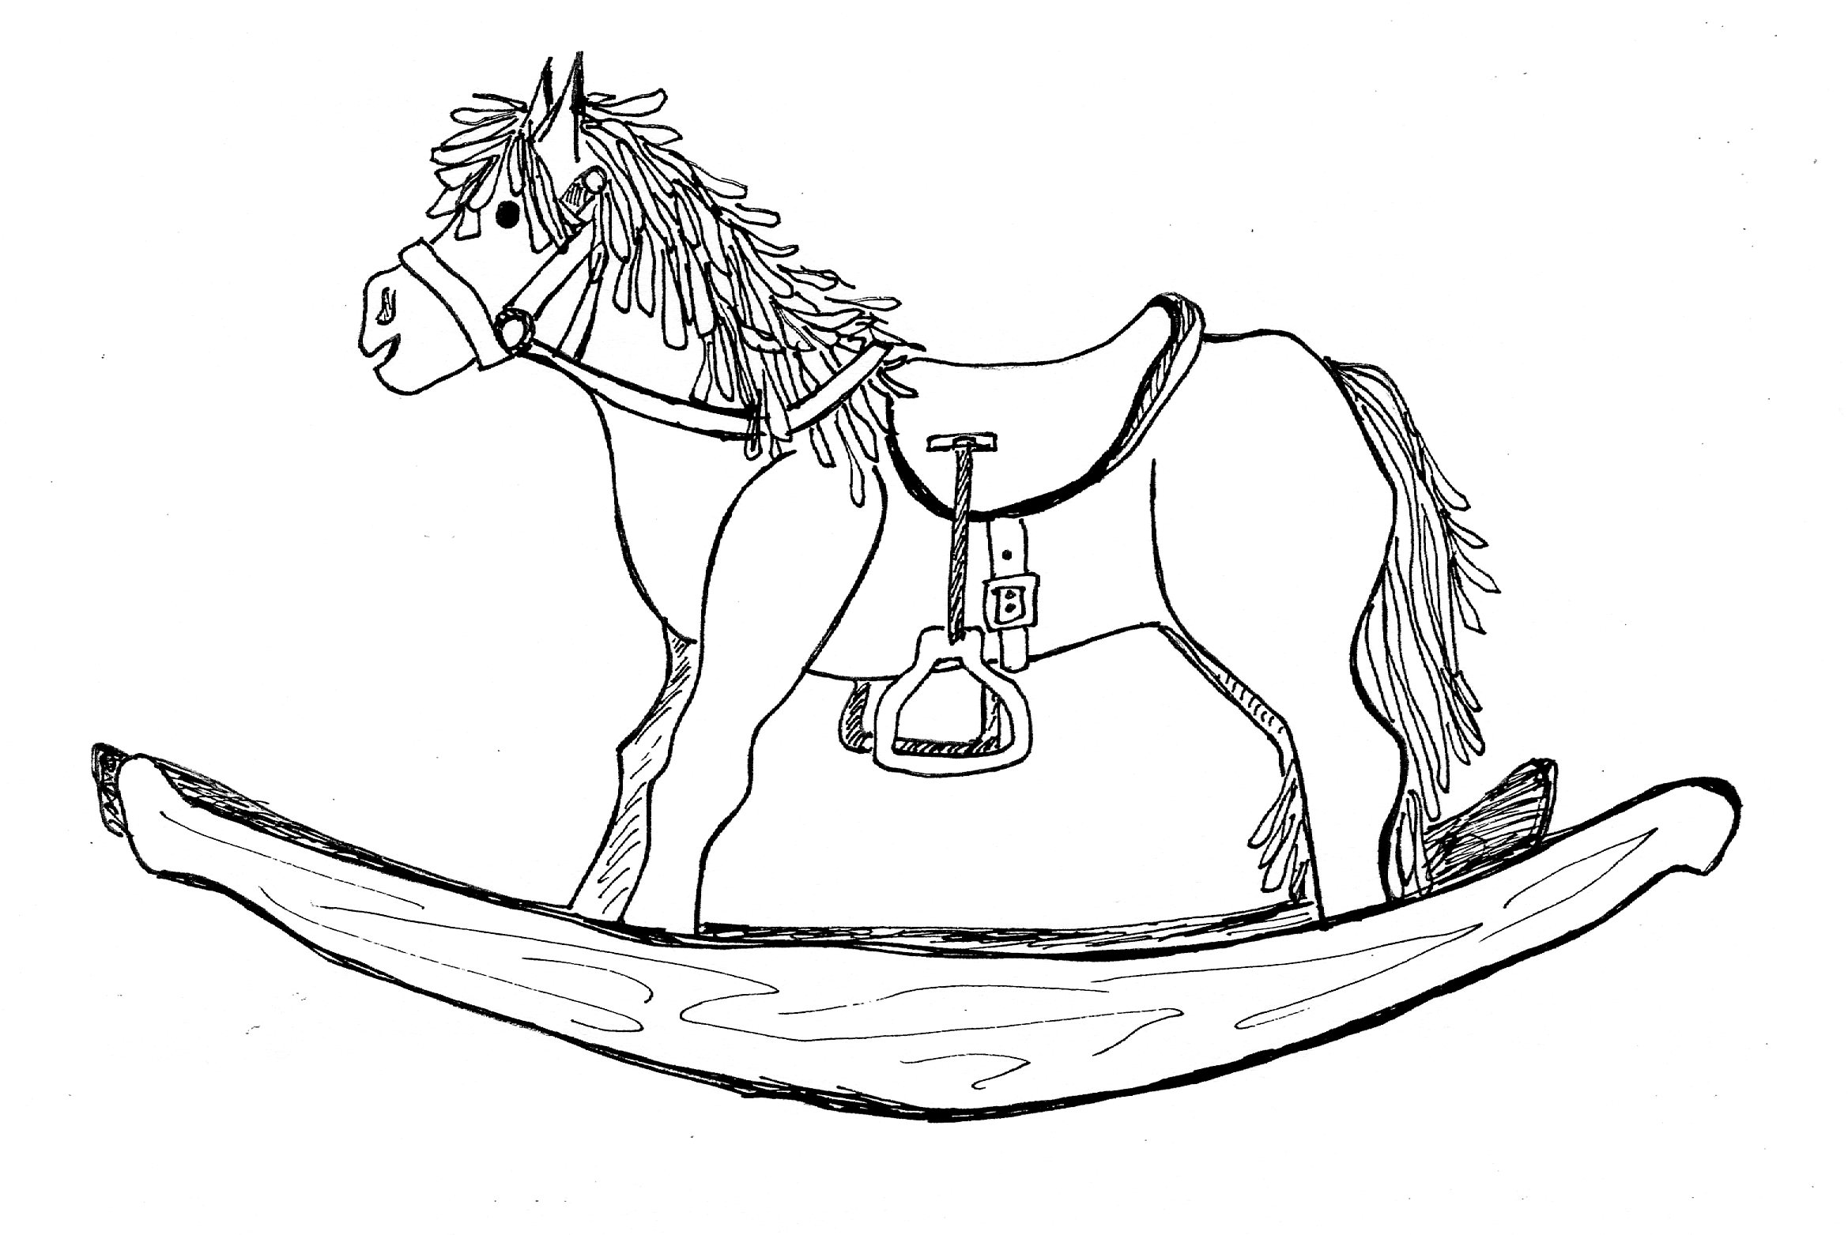
Children’s Corner
See the exhibit before it closes forever in December! There is great information for students working on school projects and for those budding history buffs in your family. Diven’s Den is also set up with children’s activities for all ages. The “den” is located on the lower level of the museum. Bring the kids for a tour and some fun!

The Laurel Historical Society has been creating holiday ornaments for almost twenty years, and currently has 18 offered for sale of various city landmarks, including the Laurel Christmas Tree, Old Liz Fire Truck, the Avondale Mil, The Laurel Museum and Main Street. Ornaments cost $18. Be sure to stop in and purchase the 2016 ornament celebrating The Laurel Theater. Add this quality ornament to your Laurel collection. The Museum shop has many items available for your own use or to give as gifts.

All proceeds benefit the LHS and members receive a 10% discount every day. Please visit our Museum shop in person during Museum hours or on line at laurelhistoricalsociety.org. To receive orders by Christmas they must be ordered by December 16th.
Want to learn more about the Laurel Theater? Read Kevin Leonard’s two History Matters stories that appeared this summer in the Laurel Leader:
Part I: http://www.baltimoresun.com/news/maryland/howard/laurel/ph-ll-history-theater-0707-20160707-story.html.
and
Part II: http://www.baltimoresun.com/news/maryland/howard/laurel/ph-ll-history-theater2-0811-20160804-story.html.

EARLY MORNING ALONG LAUREL LAKE

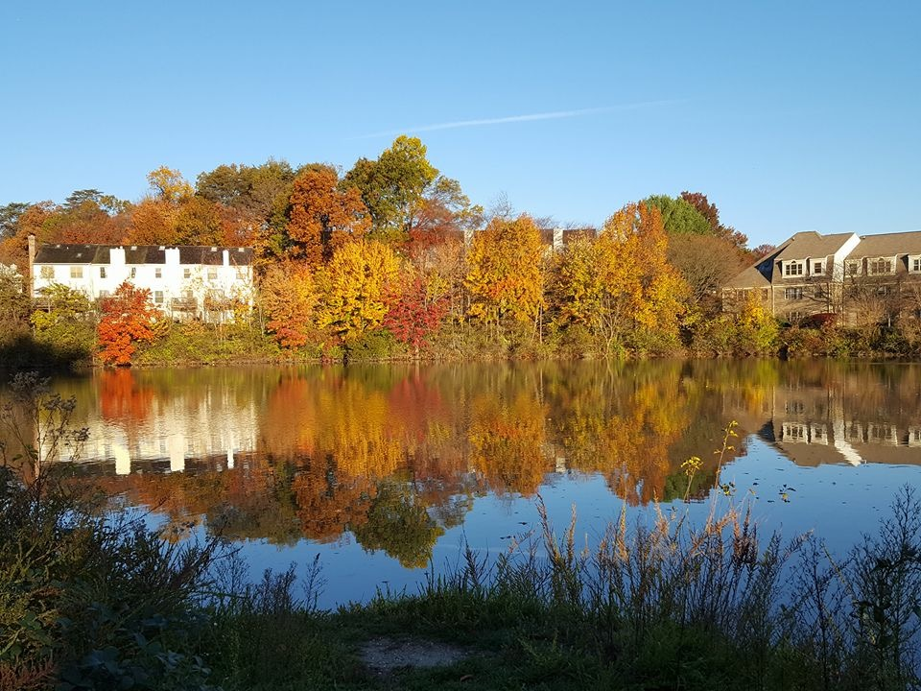

Karen Lubieniecki took this beautiful photo in November from the path around Laurel Lake. Karen and her husband Ken, as well as other friends and neighbors, enjoy our City every morning capturing these beautiful images.

Thank you Karen!

JOIN US!!

Are you reading this newsletter but not a member? We’d love for you to join!

Membership enables the Society to:
* Sustain the Laurel Museum
* Research Laurel history
* Preserve artifacts
* House a research library
* Host special children’s events
* Develop educational materials for schools and scout groups

Membership benefits include:
* Quarterly Newsletter with articles about Laurel history, museum exhibits and programs
* Member’s only events
* Member’s only discount in the museum shop
* Discounts on LHS events, including our annual gala
* Contributing to the preservation of Laurel’s past and present for future generations

Join today by visiting laurelhistoricalsociety.org.



And that’s a wrap for this edition of The Laurel Light!
Adriana Lily Cruz

Laurel Historical Society
817 Main Street
Laurel, Maryland 20707
301.725.7975
info@laurelhistoricalsociety.org
laurelhistoricalsociety.org
Address Service Requested

Lindsey Baker, Executive Director
Monica Sturdivant, Assistant to the Director

Board of Directors:
Jhanna Levin, Chairman of the Board
Elizabeth Compton, Founding Co-Director
Steve Hubbard, President
Frances Brooks, Vice President
Mariam Thakkar, Treasurer
Marlene Frazier, Recording Secretary
Amy Graver, Corresponding Secretary
Jeanie Anastasi
Mitzi Betman
Michael Boivin, Sr.
Tom Dernoga
Chris Erdle
Lisa Everett
Alicia Fields
Richard Friend
Karen A. Lubieniecki
Margie McCeney
Paula Schuman
The Hon. Craig A. Moe (ex officio)
Gertrude L. Poe, Director Emerita
Joseph Robison, Director Emeritus
Jean Wilson, Director Emerita

Laurel Historical Society Calendar
December 2016 – February 2017
For more information visit: laurelhistoricalsociety.org/pages/calendar.htm

December 2nd – 4th
Holiday Open House
Laurel Museum

December 18th, 1 – 4 PM
Closing of Exhibit

January 22nd, 2PM
Volunteer Appreciation Event

February 5th, 1 - 4 PM
Exhibit Opening

