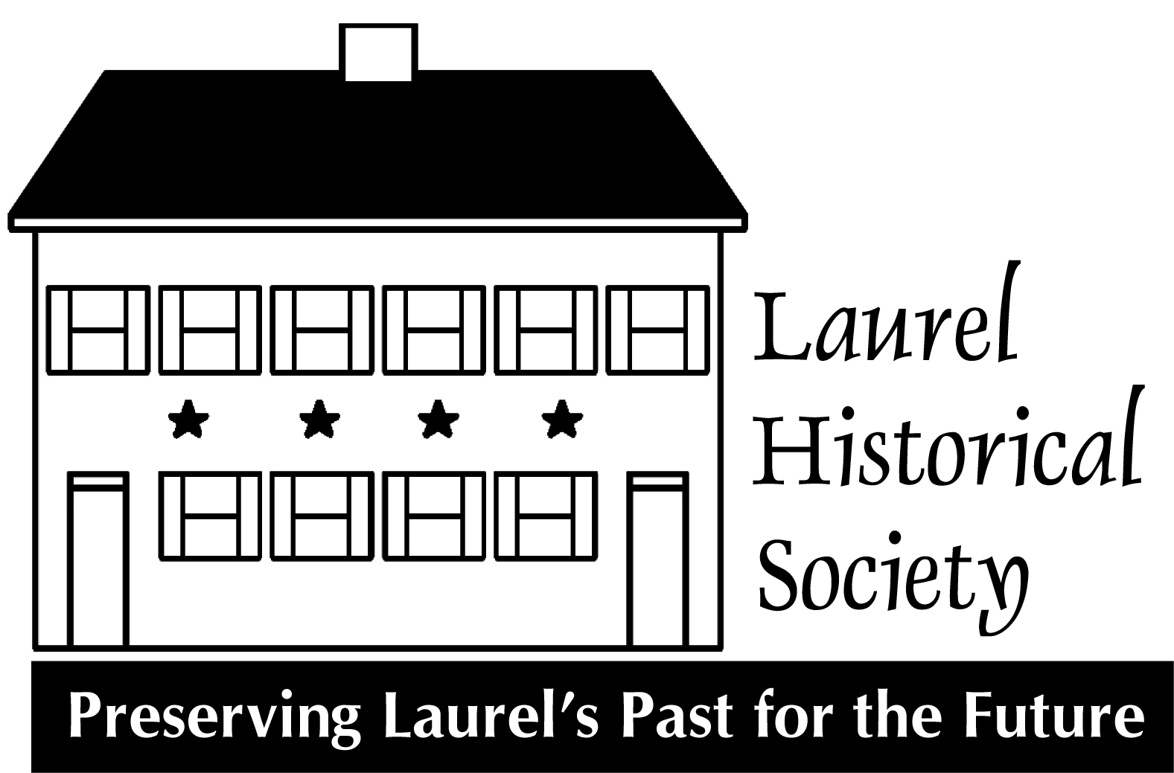

Laurel Historical Society
Volunteer Handbook

Dear Laurel Historical Society Volunteer,

Thank you so much for choosing to volunteer with the Laurel Historical Society.

The Laurel Historical Society is dedicated to encouraging the understanding and preservation of the history and cultural heritage of Laurel through exciting programs, informative exhibits, and meaningful partnerships.

Whether you join us a volunteer giving tours or helping to organize our collection, the work you do is highly valued.

Please refer to this handbook for any questions you might have, but our hope is that all volunteers feel equally comfortable speaking with Monica or myself with any questions, comments, or suggestions.

Thank you for volunteering. You are truly strengthening our organization through your efforts and for that we are grateful!

Sincerely,

Lindsey

Laurel Museum

817 Main Street
Laurel, MD 20707
301-725-7975

Hours of Operation:

Wednesday and Friday 10:00 am – 2:00 pm
Sunday 1pm-4pm
John Calder Brennan Research Library
By Appointment Only

Board of Directors & Staff
Staff:
Lindsey Baker, Executive Director director@laurelhistoricalsociety.org
Monica Sturdivant, Assistant to the Director assist@laurelhistoricalsociety.org

Laurel Historical Society Board of Directors
2015-2016
Officers:
Jhanna Levin, Chairwoman*
Steve Hubbard, President*
Abram Fox, Vice President*
Mariam Thakkar, Treasurer*
Marlene Frazier, Recording Secretary*
Amy Graver, Corresponding Secretary*
Elizabeth Compton, Co-Founder

Jeanie Anastasi
Mitzi Robison Betman
Mike Boivin
Frances Brooks
Tom Dernoga
Chris Erdle
Lisa Everett
Richard Friend*
Karen Lubieniecki*
James McCeney*
Paula Schuman
Fred Smalls
The Hon. Craig A. Moe (ex officio)

Gertrude Poe, Director Emeritus
Jean Wilson, Director Emeritus
Joseph Robison, Director Emeritus
* Member of the Executive Committee

History of the Laurel Historical Society

Early Years.
The Laurel Historical Society was organized in 1976 as the Laurel Horizon Society. Since then it has worked to preserve the cultural and historical heritage of greater Laurel.
Early projects included renovating and landscaping the B&O railroad station, placing the Avondale Mill, and the old Laurel High School (now the Edward Phelps Community Center) on the National Register of Historic Places, and developing the first walking tour of Old Town Laurel. Preservation efforts have continued to the present. The Society was instrumental in preserving the Fairall Foundry on First Street.
The Society’s May 1976 house tour began a tradition continues to this day. A slide presentation about Laurel’s history evolved into the video, "Laurel: Historic Crossroads." Funded by a generous grant from the Citizens National Bank, (now PNC) the video won a national award from the American Association of Museums, and is available in the museum shop on DVD.

The 1980s-1996: In Pursuit of a Museum
From its founding, the Society welcomed donations of material related to the history of Laurel. By the 1980s artifacts were accumulating with no place to store them. During this period the Society continued its efforts with oral histories, and preservation projects.
In 1989, the City of Laurel began exterior restoration of a mill workers’ house it owned just east of the former site of the Laurel Cotton Mill and adjacent to Riverfront Park.
On February 25, 1991, then-Mayor Joseph Robison and the Laurel City Council adopted a resolution authorizing the Laurel Historical Society to use the mill workers' house as the Laurel Museum. As plans were developed, funds raised and construction begun, traveling exhibits presented throughout the community kept citizens informed about the Museum’s progress.

1996-Present: The Laurel Museum and a Growing Society
The Laurel Museum opened its doors to the public in May 1996. Its first exhibit, from Mill House to Museum documented the history of the house and its renovation. Since then The Laurel Museum has mounted fifteen major exhibitions, including its most recent: Stationed in Laurel: Our Civil War Story. It has greeted more than 20,000 visitors, including countless schoolchildren and numerous tour groups. LHS membership grew from 31 paid members in the early nineties to the current membership of more than 300. The previously all-volunteer staff now includes a paid full-time Executive Director and part-time assistant.
Throughout its history the Society has worked to ensure that the Laurel Museum and the Society’s collection are maintained to the highest professional standards. An interpretive plan and collections policies and procedures ensure that the artifacts entrusted to our care are preserved, recorded and remain accessible through exhibits and to researchers. In 2007 the LHS undertook a strategic planning process to guide its development for the next five years.
Recent Society highlights include development of an extensive new Walking Tour of Laurel, which complements a new marker program implemented by the City. The Society holds monthly programming tied into current exhibits and local history and culture and has increased its community partnerships. Presentations through a speaker's bureau brings local history to schools as well as community and senior groups. Children’s programs are reaching out into the community while the membership continues to grow. The Taste of Laurel brings together local family-based restaurants for the community to enjoy and support. Since 2001 the Society has held an annual gala that raises critical funds to support the Society’s operations and the Laurel Museum.

Volunteer Duties
Laurel Museum Docent
As a docent, you will act as a guide to museum visitors.
-Always welcome visitors to the museum.
- Ask them to sign our guest book. Tell them a little about the history of the house and encourage them to visit the kitchen area downstairs before they leave.
-Tell them about the current exhibit and show them where it starts (if there is a specific starting place). Give them space/time to explore the exhibit and let them know that you welcome any questions. (If you are asked a question that you are unable to answer, let them know that they can leave a message for a staff member at info@laurelhistoricalsociety.org or 301-725-7975.)
-If you are giving a group tour (eight or more people), you will guide them throughout the exhibit. Group tours are usually scheduled in advance and we try to schedule volunteers who are comfortable with speaking to groups about the exhibit. However, we do occasionally have groups that show up without advance notice. If you are uncomfortable with giving an unexpected group tour, let a staff member know and we will come downstairs to give the tour. If a staff member is not available, politely tell the group leader that a group tour volunteer is not scheduled for the day (let them know that group tours are scheduled in advance) and encourage them to leave a message for a staff member at 301-725-7975 or info@laurelhistoricalsociety.org. Also, encourage them to take a self guided tour and visit the kitchen area of the museum.
-The second floor is closed to the public, so please make sure that visitors only explore the first floor and the basement.

Gift Shop Volunteer
Our gift shop volunteers are often also docents who can perform shop sale transactions.
-Always welcome visitors to the kitchen area of the house and tell them about the history of the space.
-Encourage them to visit the gift shop.
-If they have never visited, show them the different items that we offer. Remember to highlight best sellers (ornaments, throws) and any newly acquired merchandise.
-Always enter the items purchased into the iPad Square and write a sales ticket. Give the customer the yellow copy and keep the white copy in the sales envelope for the day.

Committee Volunteer
Committee volunteer duties vary; they depend on the objectives of the committee. A lot of the work is done behind the scenes. Let us know if you are interested in helping with the gala, coordinating events, maintaining the collection and/or participating in offsite events. We will put you in touch with the contact person for the appropriate committee.

FREQUENTLY ASKED QUESTIONS
Q: Are there other ways to volunteer with the Laurel Historical Society besides being a docent?
A: Absolutely! Volunteers maintain our collection, assist with research, help with mailings, coordinate public programs, plan special events and so much more. If you have any questions and you would like to become involved with other areas of the Laurel Historical Society, please contact us at 301-725-7975 or assist@laurelhistoricalsociety.org.

Q: If it snows, how will I know if the museum is closed or if a Laurel Historical Society event is cancelled?
A: The Laurel Historical Society follows Prince George’s County Public Schools’ inclement weather announcements. (If Prince George’s County Public schools are closed or delayed, we are closed or delayed.) More details are in the Inclement Weather Policy section of the handbook.

Q: What should I do if a visitor comes into the museum and makes a request for research?
A: Research is by appointment only. The visitor can submit a research request at research@laurelhistoricalsociety.org or they may leave a written request (with contact information) for the assistant to the director.

Q: Is the second floor open to the public?
A: No, the second floor is for staff and volunteers only. There is no exhibit space on the second floor. The research library is available by appointment only.

Q: What if a visitor shows up with an object to donate?
A: Thank the visitor for the donation and have him/her complete a Temporary Custody form; they are in a folder in a drawer of the volunteer desk. Let the visitor know that the collections committee makes decisions about what objects become a part of the collection. (If they have any questions when staff is not available, they can call 301-725-7975 or email info@laurelhistoricalsociety.org.) Put the object and completed form on the collections table. (The collections table is on the second floor on the left side of the kitchen entrance.)

Q: If the phone rings when staff is not available, should I answer it?
A: Yes; we would greatly appreciate it! You can answer the phone by saying, “Laurel Museum.” There should be a message book and pen on the volunteer desk. Let the caller know that staff is not available at the moment, but they may contact us via email (info@laurelhistoricalsociety.org). If the caller specifically asks for the director, the email address is director@laurelhistoricalsociety.org. If the caller is unable to email and would prefer to leave a message with you, please write the message and leave it for us at the volunteer desk.

Q: What if a visitor wants me to keep the museum open after closing time?
A: Politely tell them that the museum is now closed and remind them of our next opening time. (If possible, begin the closing procedure about five minutes before closing time.) It also helps to remind visitors of the approaching closing time. (“The museum will be closing in fifteen minutes.)

Inclement Weather Policy
Laurel Museum

Museum Closed Due to Weather (Monday – Friday)
When Prince George’s County Public Schools are closed due to inclement weather, the
Laurel Museum will be closed.

Staff and volunteers should check radio, television or internet news to learn whether schools are closed or delayed.

The Assistant to the Director will contact the leader of any group tours scheduled unless the group follows the Prince George’s County Public School schedule.

Museum Delayed Opening Due to Weather (Monday –Friday)
When Prince George’s County Public Schools have a delayed opening due to inclement weather, the Laurel Museum will open at noon.

Volunteers scheduled from 10 AM – 12 PM should not report. Staff should report by 10 AM if possible. Volunteers scheduled for the PM shift should contact the Assistant to the Director as soon as possible if they are unable to report at noon.

The Assistant to the Director will contact the leader of any tour groups scheduled. Messages should be left at schools even though schools usually cancel all field trips when opening is delayed.

Museum Closed Due to Weather (Sundays)
When Prince George’s County events are closed due to weather or when it is unlikely that the city will be able to clear the walks at the museum, the museum will be closed.

An announcement will be recorded at the museum’s phone number by 11 AM to state that the museum will be closed that day.

Volunteers should check to see if the museum will be open before traveling to the museum.

Volunteers should contact the Assistant to the Director as soon as possible if they are unable to report.

When group leaders schedule a Sunday, they should call before coming during inclement weather.

Evening Tours
The volunteer assigned to be in charge of an evening tour will be given contact information for the group tour leader.

The volunteer will coordinate with the group tour leader and other scheduled volunteers to decide whether the tour will be rescheduled.

DISRUPTIVE VISITORS
First, try tactfully asking visitor to change their behavior.
If visitor is behaving in a manner that prevents other visitors from enjoying the exhibit or hearing the guide, politely ask them to lower their voice so other visitors can enjoy the exhibit.

Contact the director or assistant to the director or another volunteer for assistance if necessary.

If the visitor becomes unruly:
Tell them specifically what is unacceptable about the behavior (loud, hostile, rude to volunteers or others, or acting in a manner that is not safe for exhibits, staff or self).

Tell them you will need to ask them to leave if they do not modify their behavior to be acceptable.

Contact the director or assistant to the director or another volunteer for assistance if necessary.
If they do not modify their behavior, ask them to leave.

If they refuse to leave, tell them “You must leave the museum now or I will contact the police.” Be sure this time to tell them to leave. Do not say “ask” or anything to indicate it is a request and not a director order.

Call the police if they do not leave. Laurel Police: 301-498-0092
Many unruly people have been ordered to leave other places, so they often know how long it can take for police to respond. There is a strong possibility that they will not leave until just before the police arrive.

If they do not leave when you tell them to leave, say the following:

“Because you have been disruptive to the operation of the museum and have not left after I told you to leave, you are forever banned from the Laurel Museum. Do not return or I will call the police again.”

